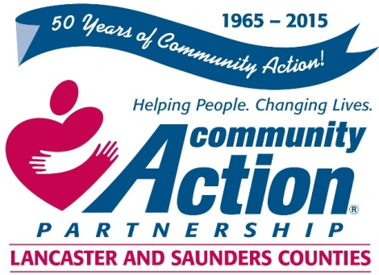

Community Action Partnership of Lancaster and Saunders Counties is a private,
not-for-profit organization with the belief that extraordinary employees have the power to
positively transform lives and communities. We value people who are passionate, ethical,
and dedicated to empowering those living in poverty to reach economic stability.

Head Start Co-Teacher

The successful applicant will:

- Work cooperatively with the Lead Teacher to plan and implement the daily education program for the children.
- Assist in the planning and implementation of developmentally appropriate classroom activities that will enhance the social, emotional, physical and cognitive development of each child.
- Observe, assess and document each assigned child’s health, skills, behavior, growth and development.
- Ensure the education program is developmentally appropriate meeting the individual needs of children as well as program standards.
- In the absence of the Lead Teacher, take responsibility for the management of the classroom.

Minimum of an Associate’s degree in Early Childhood or similar degree required. Minimum of one year experience working with young children and their families in a day care or related setting preferred.
You will find complete job listing and details at the following websites:
Communityactionatwork.org
Careerlink.com
Neworks.nebraska.gov

Resumes and cover letters should be sent to:
mandrews@communityactionatwork.org

Community Action Partnership of Lancaster and Saunders Counties is an equal opportunity employer and does not discriminate on the basis of race, color, religion, national origin, marital status, veteran status, political affiliation, sexual orientation or gender identity, disability, sex, age or any other status protected by state or federal law.

