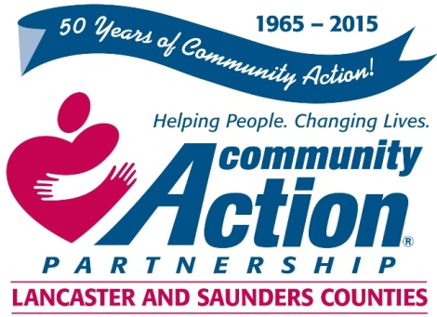

Community Action Partnership of Lancaster and Saunders Counties is a private, not-for-profit
organization with the belief that extraordinary employees have the power to positively transform lives
and communities. We value people who are passionate, ethical, and dedicated to empowering those
living in poverty to reach economic stability.

Early Head Start/Head Start Family Engagement Specialist

The successful applicant will:

Coordinate the overall integration of services to families as they relate to early childhood education, health, mental health, social-emotional and parent education services.

Team with teaching and administrative staff to develop and implement family engagement opportunities to enhance family well-being, promote positive parent-child relationships, support family members as lifelong educators, engage family members as learners, inform families during the transition of their children from one developmental program to another, connect family members to peers and their community and promote family members’ abilities to advocate and serve as leaders in their community.

Assist families as needed to address crisis events that may impact a child’s regular participation in the program and/or relate to basic family needs.

Bachelor’s Degree in Human Services or Social Work (preferred) or related field (Education, Child, Youth and Family Studies, Psychology). Two years experience working in a community-based, culturally and/or social economically diverse, family-centered program. Previous Head Start or Early Childhood Experience preferred. Valid Nebraska Driver’s License and good driving record required.

You will find complete job listing and details at the following websites:
Communityactionatwork.org
Careerlink.com
Neworks.nebraska.gov

For information regarding the Family Engagement Specialist job, contact
Human Resources at 402-875-9315 or
mandrews@communityactionatwork.org

Resumes and cover letters should be sent to:
mandrews@communityactionatwork.org

Community Action Partnership of Lancaster and Saunders Counties is an equal opportunity employer and does not discriminate on the basis of race, color, religion, national origin, marital status, veteran status, political affiliation, sexual orientation or gender identity, disability, sex, age or any other status protected by state or federal law.

