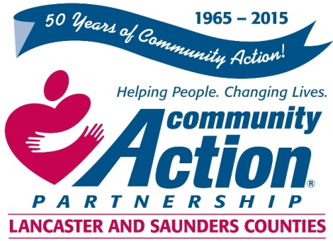

Community Action Partnership of Lancaster and Saunders Counties is a private,
not-for-profit organization with the belief that extraordinary employees have the power to
positively transform lives and communities. We value people who are passionate, ethical,
and dedicated to empowering those living in poverty to reach economic stability.

Weatherization Inspector

The weatherization program is looking for an outstanding individual to join our team. If you enjoy work that is always changing and challenging with hands-on fieldwork as well as paperwork and computer skills, this is the job for you! We are searching for a highly-motivated, independent problem-solver with a passion for learning new things.

The Weatherization Inspector will inspect homes to determine work to be completed and determine any corrective actions needed to ensure the safety, comfort, and energy savings of the building occupants.

Key responsibilities of our Weatherization Inspector include:
- Conduct initial inspections of properties to determine eligibility of properties.
- Gather information/measurements and perform diagnostic testing on eligible properties.
- Communicate with homeowners regarding recommended measures and repairs.
- Enter inspection information into audit software.
- Prepare work orders for contractors and follow-up to ensure timely work is completed.

High School Diploma or GED required. Three to five years experience with and knowledge of the
building trade preferred. Valid driver’s license and good driving record required. Must be sensitive to
the barriers experienced by individuals and families living in poverty.

For more information please contact Human Resources at 402-875-9315 or
mandrews@communityactionatwork.org

Resumes and cover letters should be sent to:
mandrews@communityactionatwork.org

***
Community Action Partnership of Lancaster and Saunders Counties is an equal opportunity employer and does not discriminate on the basis of race, color, religion, national origin, marital status, veteran status, political affiliation, sexual orientation or gender identity, disability, sex, age or any other status protected by state or federal law.

