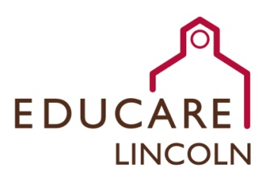
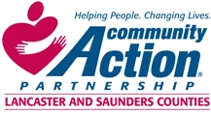

Office Specialist

Educare of Lincoln is seeking a detail-oriented individual to oversee the office operations of Educare of Lincoln, a full day, full year school serving children ages birth to five years and their families. In this fast-paced early learning environment, the Office Specialist ensures that we operate efficiently and keep up with the needs and requests of staff, families, and the greater Lincoln community.
Key Responsibilities of this Position include:
- Oversee billing, family fee collection and troubleshooting, credit card check out and use, and voucher submission to Community Action.
- Help create a welcoming reception area for families, partners, and community members.
- Ensure funded enrollment of children is maintained and support families with the application process. Complete enrollment applications with families as needed.
- Order supplies and maintain current inventory.
- Collaborate with Community Action’s Volunteer Resources Coordinator to place, train, and support volunteers serving Educare of Lincoln.
- Assist Educare of Lincoln leadership in ensuring quality program operation per State of Nebraska licensing regulations, Head Start Performance Standards, and Educare guidelines.
- Monitor facility cleaning and maintenance in partnership with Lincoln Public Schools staff.
- Complete enrollment applications with families as needed.
- Enter data in program data information system.
A minimum of an Associate’s Degree in Early Childhood Education, Human Services, Child, Youth and Family Studies, Business, or related field preferred. Bachelor’s Degree preferred. 1-2 years of experience with leading office operations required. Experience working with diverse and/or vulnerable populations in a professional capacity, particularly with young children and their families, is strongly preferred. Strong verbal and written proficiencies of the English language required. Intermediate to high typing and computer use proficiency required.

For more detailed information, or to submit application materials, please contact Human Resources at 402-875-9315 or mandrews@communityactionatwork.org.

***
Community Action Partnership of Lancaster and Saunders Counties is an equal opportunity employer and does not discriminate on the basis of race, color, religion, national origin, marital status, veteran status, political affiliation, sexual orientation or gender identity, disability, sex, age or any other status protected by state or federal law.

Community Action Partnership of Lancaster and Saunders Counties is a private,
not-for-profit organization with the mission of empowering people living in
poverty to achieve economic stability.

