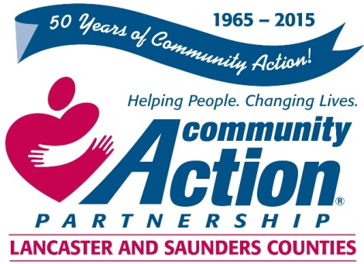

Community Action Partnership of Lancaster and Saunders Counties is a private,
not-for-profit organization with the belief that extraordinary employees have the power to
positively transform lives and communities. We value people who are passionate, ethical,
and dedicated to empowering those living in poverty to reach economic stability.

Early Head Start and Head Start Health Services Coordinator

The successful applicant will:

- Be responsible for the provision and coordination of health services to children and families.
- Supervise and monitor the safety practices and food services program.
- Observe, assess and document each assigned child’s health, skills, behavior, growth and development.
- Assist the Health Services Manager in providing formal and informal training and/or consultation to the staff and families.

Associate’s degree in Nursing, Social Work, Health Education, Public Health or a related field required.

Significant work experience may substitute for education requirement. Experience navigating the health

care system preferred. Education or experience pertaining to the unique health needs of young children

preferred. Experience monitoring or evaluating program practices preferred. Experience working with

low-income families and families with diverse backgrounds and cultures.

You will find complete job listing and details at the following websites:
Communityactionatwork.org
Careerlink.com
Neworks.nebraska.gov

For more information please contact Human Resources at 402-875-9315 or
mandrews@communityactionatwork.org

Resumes and cover letters should be sent to:
mandrews@communityactionatwork.org

Community Action Partnership of Lancaster and Saunders Counties is an equal opportunity employer and does not discriminate on the basis of race, color, religion, national origin, marital status, veteran status, political affiliation, sexual orientation or gender identity, disability, sex, age or any other status protected by state or federal law.

