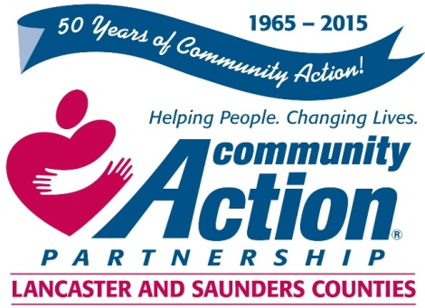

Community Action Partnership of Lancaster and Saunders Counties is a private,
not-for-profit organization with the belief that extraordinary employees have the power to
positively transform lives and communities. We value people who are passionate,
ethical, and dedicated to empowering those living in poverty to reach economic stability.

Lead Teacher

The successful applicant will:

Plan and implement developmentally appropriate classroom activities for children ages 6 weeks
to 5 years that will enhance:
- Language and literacy and problem-solving development,
- Cognition and general knowledge,
- Approaches toward learning,
- Physical well-being and motor development,
- Social and emotional development of each child, and
- Provide day-to-day supervision of classroom staff.

Minimum of Associates in Early Childhood or a Bachelor’s in a related field with the equivalent of an Early Childhood major and experience working with children in a child care setting.

Minimum of one year experience working with young children and their families in a child care or related setting required. Strong verbal and written proficiency of the English language required.

You will find complete job listing and details at the following websites:
Communityactionatwork.org
Careerlink.com
Neworks.nebraska.gov

For information regarding benefits please contact Human Resources at
402-875-9315 or mandrews@communityactionatwork.org

Resumes should be sent to mandrews@communityactionatwork.org

***
Community Action Partnership of Lancaster and Saunders Counties is an equal opportunity employer and does not discriminate on the basis of race, color, religion, national origin, marital status, veteran status, political affiliation, sexual orientation or gender identity, disability, sex, age or any other status protected by state or federal law.

