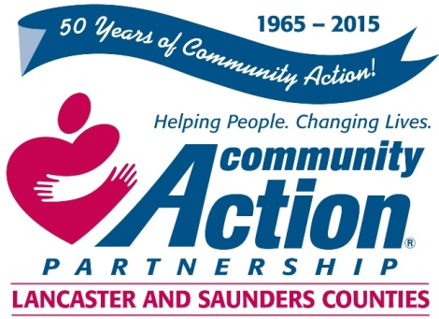 

Community Action Partnership of Lancaster and Saunders Counties is a private,

not-for-profit organization with the belief that extraordinary employees have the power to

positively transform lives and communities. We value people who are passionate,

ethical, and dedicated to empowering those living in poverty to reach economic stability.

**Food Service Coordinator**

Community Action is looking for a Food Service Coordinator to assist in planning and implementing the daily meals and snacks for children and staff.

The successful applicant will:

* Be responsible for the planning and production of healthy meals for approximately 255 children enrolled in the Head Start program.
* Coordinate the overall operations in the kitchen.
* Organize and direct the processes necessary to provide breakfast, lunch, and snacks that meet Head Start and Early Head Start and CACFP standards.
* Requisition food, supplies and equipment to maintain stock levels.
* Receive and verify all deliveries, maintaining proper storage conditions, using approved method of rotation (first in/first out), and label and date items received.

Background in institutional food service preferred. Must have or be able to acquire a Food Handler’s

Permit. Strong verbal and written proficiencies of the English language required. Must be sensitive to

barriers that families living in poverty experience. Must have a valid driver’s license and a good driving

record.

**For more information please contact Human Resources at 402-875-9315 or**

[**mandrews@communityactionatwork.org**](mailto:mandrews@communityactionatwork.org)

**Resumes and cover letters should be sent to:**

[**mandrews@communityactionatwork.org**](mailto:mandrews@communityactionatwork.org)

***

Community Action Partnership of Lancaster and Saunders Counties is an equal opportunity employer and does not discriminate on the basis of race, color, religion, national origin, marital status, veteran status, political affiliation, sexual orientation or gender identity, disability, sex, age or any other status protected by state or federal law.